1. Link github :

<https://github.com/hadi-web/Web-Programming-II/tree/master/praktikum%203>

1. Source Code

* Controller 🡪 Matakuliah.php
* Views 🡪 view-form-matakuliah.php

1. 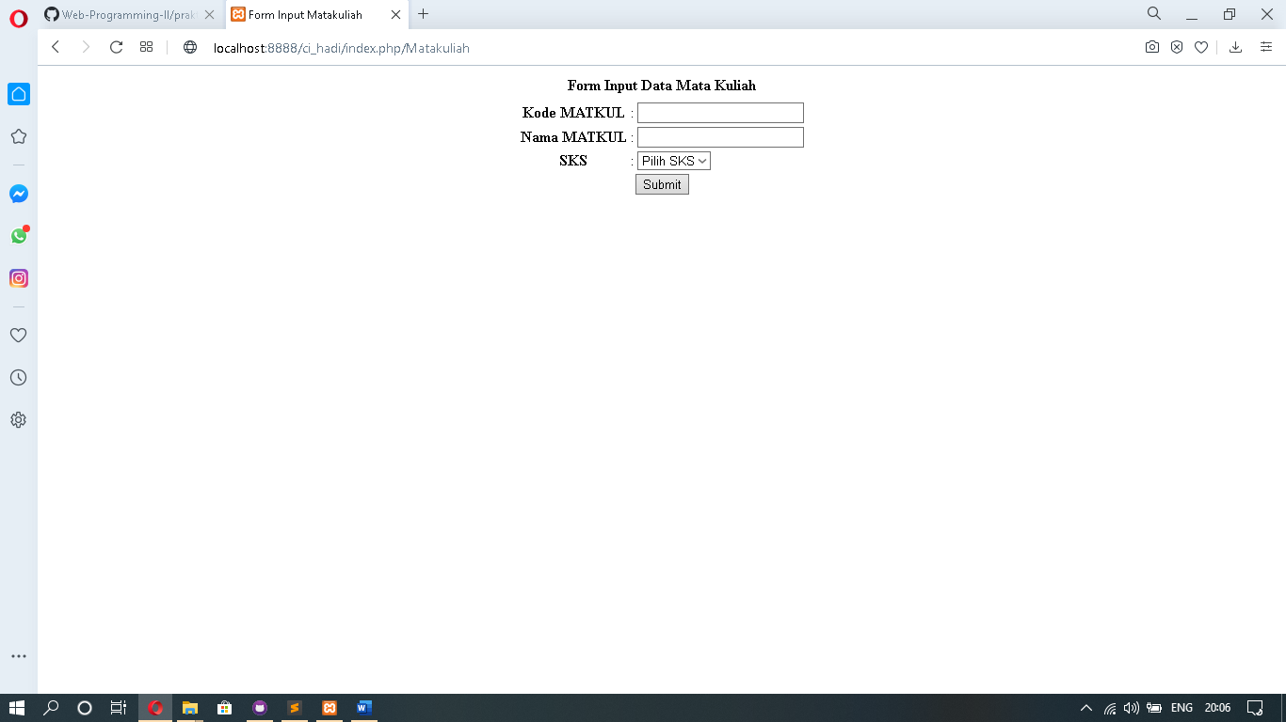Screen Shoot